Northmead Drove, Puriton

Neighbourhood Planning Site Assessment Template

Site Details
Detail | Assessment
Site Reference / Name | CFS001
[Insert site plan showing boundary of site] | 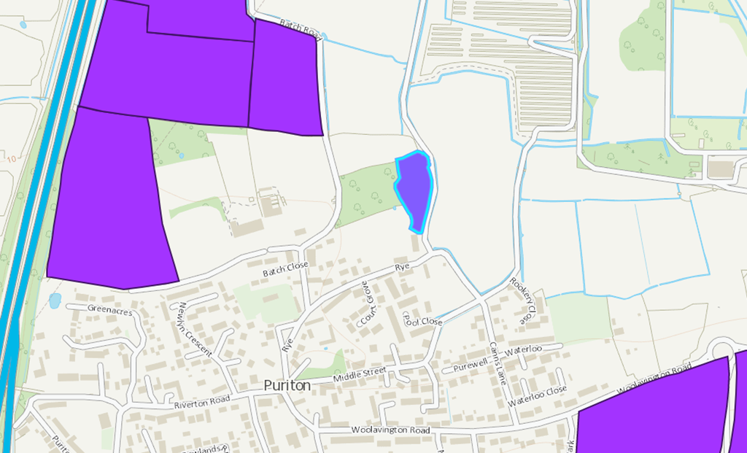
Site Address / Location | Northmead Drove
Gross Site Area (Hectares) | 24
SHLAA/SHELAA Reference (if applicable) | N/A
Existing land use | Equestrian
Land use being considered, if known (e.g. housing, community use, commercial, mixed use) | Residential and retail
Landowner estimate of development capacity (if known) | 150
Site identification method / source  (e.g. SHELAA, Call for Sites consultation, identified by neighbourhood planning group) | CFS
Planning history  (Live or previous planning applications/decisions) | None
Neighbouring uses | Motorway, sports centre, agricultural, housing

Assessment of Suitability

Environmental Constraints
Indicator of Suitability | Assessment
Site is predominantly, or wholly, within or adjacent to the following statutory environmental designations:  Ancient Woodland  Area of Outstanding Natural Beauty (AONB)  Biosphere Reserve  Local Nature Reserve (LNR)  National Nature Reserve (NNR)  National Park  Ramsar Site  Site of Special Scientific Interest (SSSI)  Special Area of Conservation (SAC)  Special Protection Area (SPA)  Yes/ No/ Unknown  Does the site fall within a SSSI Impact Risk Zone and would the proposed use/development trigger the requirement to consult Natural England?  Yes/ No/ Unknown | No  No
Site is predominantly, or wholly, within or adjacent to the following non statutory environmental designations:  Green Infrastructure Corridor  Local Wildlife Site (LWS)  Public Open Space  Site of Importance for Nature Conservation (SINC)  Nature Improvement Area  Regionally Important Geological Site  Other  Yes/ No/ Unknown | Sports Centre
Site is predominantly, or wholly, within Flood Zones 2 or 3?  See guidance notes:  Flood Zone 1: Low Risk  Flood Zone 2: Medium Risk  Flood Zone 3 (less or more vulnerable site use): Medium Risk  Flood Zone 3 (highly vulnerable site use): High Risk | Approximately 50% of site falls within FZ3. Southern end does not fall within a FZ.
Site is at risk of surface water flooding?  See guidance notes:  Less than 15% of the site is affected by medium or high risk of surface water flooding – Low Risk  >15% of the site is affected by medium or high risk of surface water flooding – Medium Risk | No
Is the land classified as the best and most versatile agricultural land (Grades 1, 2 or 3a)  Yes / No / Unknown | Site is Grade 3 (not differentiated between a and b)
Site contains habitats with the potential to support priority species?  Does the site contain local wildlife-rich habitats?  Is the site part of:  A wider ecological network (including the hierarchy of international, national and locally designated sites of importance for biodiversity);  wildlife corridors (and stepping stones that connect them); and/or  An area identified by national and local partnerships for habitat management, enhancement, restoration or creation?  Yes / No / Unknown | Unknown
Site is predominantly, or wholly, within or adjacent to an Air Quality Management Area (AQMA)?  Yes / No / Unknown | No

Physical Constraints
Indicator of Suitability | Assessment
Is the site:  Flat or relatively flat  Gently sloping or uneven  Steeply sloping | Gently sloping
Is there existing vehicle access to the site?  Yes / No / Unknown | No
Is there existing pedestrian/cycle access to the site?  Pedestrian?  Yes / No / Unknown  Cycle?  Yes / No / Unknown | Yes  No
Are there any known Tree Preservation Orders on the site?  Yes / No / Unknown | No
Are there veteran/ancient or other significant trees within or adjacent to the site? Are they owned by third parties?  Significant trees?  Yes, within / Yes, adjacent / No / Unknown  Potentially veteran or ancient trees present?  Yes, within / Yes, adjacent / No / Unknown  Owned by third parties?  Yes / No / Unknown | No  Unknown  Unknown
Are there any Public Rights of Way (PRoW) crossing the site?  Yes / No / Unknown | No
Is the site likely to be affected by ground contamination?  Yes / No / Unknown | No
Is there any utilities infrastructure crossing the site i.e. power lines/pipe lines, or is the site in close proximity to hazardous installations?  Yes / No / Unknown | Power lines
Would development of the site result in a loss of social, amenity or community value?  Yes / No / Unknown | No

Accessibility
Factor |  | Guidance
Distances to community facilities and services should be measured using walking routes from the centre of each site to each facility. Additional facilities can be added to the list. The distances are based on the assumption that 400m is equal to approximately 5 minutes’ walk. This can be measured using Google Maps:
What is the distance to the following facilities (measured from the edge of the site) | Distance  (metres) |  | Comments
Town / local centre / shop | 400-1200m
Bus /Tram Stop | 400-800m
Train station | <400m  400-1200m  >1200m |  | No train station in the Parish
Primary School | 400-1200m
Secondary School | <1600m  1600-3900m  >3900m |  | No secondary school in the Parish
Open Space / recreation facilities | 400-800m
Cycle Route | 400-800m

Landscape and Visual Constraints
This section should be answered based on existing evidence (see guidance notes) or by a qualified landscape consultant.
Indicator of Suitability | Assessment
Is the site low, medium or high sensitivity in terms of landscape?  Low sensitivity: the site has few or no valued features, and/or valued features that are less susceptible to development and can accommodate change.  Medium sensitivity: the site has many valued features, and/or valued features that are susceptible to development but could potentially accommodate some change with appropriate mitigation.  High sensitivity: the site has highly valued features, and/or valued features that are highly susceptible to development. The site can accommodate minimal change. | Low
Is the site low, medium or high sensitivity in terms of visual amenity?  Low sensitivity: the site is visually enclosed and has low intervisibility with the surrounding landscape, and/or it would not adversely impact any identified views.  Medium sensitivity: the site is somewhat enclosed and has some intervisibility with the surrounding landscape, and/or it may adversely impact any identified views.  High sensitivity: the site is visually open and has high intervisibility with the surrounding landscape, and/or it would adversely impact any recognised views. | Medium

Heritage Constraints
Indicator of Suitability |  | Assessment
Would the development of the site cause harm to a designated heritage asset or its setting?  Directly impact and/or mitigation not possible  Some impact, and/or mitigation possible  Limited or no impact or no requirement for mitigation | Limited or no impact or no requirement for mitigation
Would the development of the site cause harm to a non-designated heritage asset or its setting?  Directly impact and/or mitigation not possible  Some impact, and/or mitigation possible  Limited or no impact or no requirement for mitigation | Limited or no impact or no requirement for mitigation

Planning policy constraints
Indicator of Suitability | Assessment
Is the site in the Green Belt?  Yes / No / Unknown | No
Is the site allocated for a particular use (e.g. housing / employment) or designated as open space in the adopted and / or emerging Local Plan?  Yes / No / Unknown | No
Are there any other relevant planning policies relating to the site? | No
Is the site:  Greenfield  A mix of greenfield and previously developed land  Previously developed land? | Greenfield
Is the site within, adjacent to or outside the existing built up area?  Within the existing built up area (infill)?  Adjacent to and connected to the existing built up area?  Outside and not connected to the existing built up area? | Adjacent
Is the site within, adjacent to or outside the existing settlement boundary (if one exists)?  Within the existing settlement boundary?  Adjacent to and connected to the existing settlement boundary?  Outside and not connected to the existing settlement boundary? | Outside and not connected to the existing settlement boundary.
Would development of the site result in neighbouring settlements merging into one another?  Yes / No / Unknown | No
Is the size of the site large enough to significantly change the size and character of the existing settlement?  Yes / No / Unknown | Yes

Assessment of Availability
Indicator of Availability | Assessment
Is the site available for development?  Yes / No / Unknown. | Unknown
Are there any known legal or ownership problems such as unresolved multiple ownerships, ransom strips, tenancies, or operational requirements of landowners?  Yes / No / Unknown. | Unknown
Is there a known time frame for availability?
Available now / 0-5 years / 6-10 years / 11-15 years.

Viability
Indicators of Viability | Assessment
Is the site subject to any abnormal costs that could affect viability, such as demolition, land remediation or relocating utilities?  Yes / No / Unknown.  What evidence is available to support this judgement? | No  No buildings on the land and no utilities to move.

Conclusions
Conclusions | Assessment
Summary of key development constraints affecting the site | Road Access  Electricity pylons  Proximity to motorway  50% of site in flood zone 3
What is the estimated development capacity of the site? | 150
What is the likely timeframe for development?  (0-5 / 6-10 / 11-15 / 15+ years) | 5-10 years
Other key information | None
Overall rating (Red/Amber/Green)  The site is suitable, available and achievable  The site is potentially suitable, available and achievable  The site is not currently suitable, available and achievable | Red
Summary of justification for rating | Lack of suitable road access to the site and it is in the flood zone.


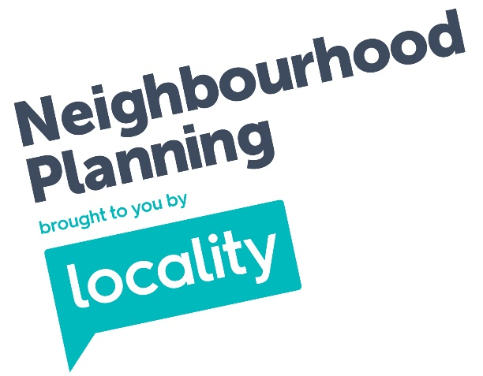
Text
Locality is the national membership network supporting community organisations to be strong
and successful.

Locality
33 Corsham Street, London N1 6DR
0345 458 8336

Locality is the trading name of Locality (UK) a company limited by guarantee, registered in England no. 2787912 and a registered charity no. 1036460.
©Locality
The content of this guidance is for your general information and use only. It is subject to change without notice. Neither we nor any third parties provide any warranty or guarantee as to the accuracy, timeliness, performance, completeness or suitability of the information offered in this guidance for any particular purpose. You acknowledge that such information may contain inaccuracies or errors and we expressly exclude liability for any such inaccuracies or errors to the fullest extent permitted by law.
Your use of this guidance is entirely at your own risk, for which we shall not be liable. It shall be your own responsibility to ensure that this guidance meets your specific requirements.
For formal Government guidance on Neighbourhood planning please visit gov.uk
Unlock the power in your community with us
locality.org.uk

